Use Cases

for

ReportNow
Version 1.0 approved
Prepared by Dylan Quek Zhi En,
Ang Wei Ming,
Chi Seo Hyeon,
Choo Kean Yee,
Madelyn Cruz Tan,
Lim Jun Howe,
Tan Yong Huat
SC3040 TEL5 Team 2
College of Computing and Data Science, Nanyang Technological University
8 September 2025
Revision History

Name | Date | Reason For Changes | Version

Table of Contents
1. Use Case Diagram 2
2. Use Case Descriptions 3
2.1 Account Management 3
2.1.1 User Registration 3
2.1.2 User Login 4
2.1.3 Manage User Account 5
2.2 Issue Tracking & Visualisation 5
2.2.1 View Issue 5
2.2.2 Filter Issue 6
2.3 Issue Reporting 7
2.3.1 Report Issue 7
2.3.2 Categorise and Assign Issue 7
2.3.3 Verify and Update Issue Status 8
2.3.4 Update Issue Status to Done 9
2.3.5 Recategorise Issue 10
2.4 Issue Review 10
2.4.1 Check Review & Rating 10
2.4.2 Leave Review 11
2.5 Notifications & Alert 12
2.5.1 Notify Users 12
2.5.2 Opt-In Notification 13

Use Case Diagram

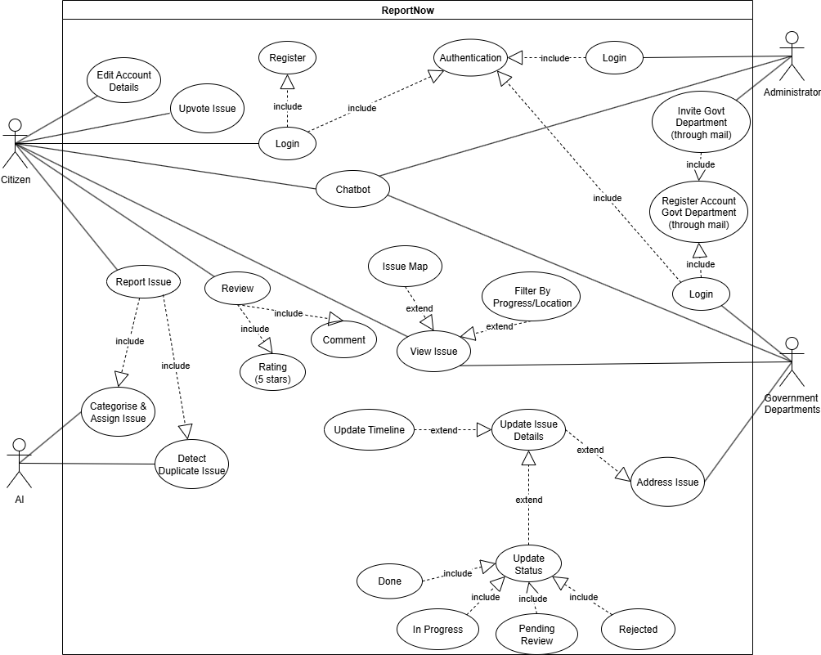

Use Case Descriptions

2.1 Account Management

2.1.1 User Registration

Use Case ID: | 1.1
Use Case Name: | User Registration
Created By: | Dylan, Wei Ming | Last Updated By: | Dylan, Wei Ming
Date Created: | 8 September 2025 | Date Last Updated: | 8 September 2025

Actor: | Citizen
Description: | Allows a citizen to register for an account
Preconditions: | None
Postconditions: | The citizen has an account created and is granted access to the system
Priority: | High
Frequency of Use: | Medium
Flow of Events: | - The system prompts the citizen to enter their name, password, email, and contact number.  - The citizen enters the required information and selects the “Create Account” button to confirm his inputs.  - The citizen receives a verification email.  - The citizen clicks on the verify link in his/her email.  - An account is created for the citizen .
Alternative Flows: | 1.1.AC.1 If the citizen selects the back navigation icon, the system will navigate the User to the login page.
Exceptions: | If any required information is missing or invalid, an  error message is displayed.
Includes: | Verify User
Special Requirements: | System needs to validate user input data.
Assumptions: | None
Notes and Issues: | None

2.1.2 User Login
Use Case ID: | 1.2
Use Case Name: | User Login
Created By: | Dylan, Wei Ming | Last Updated By: | Dylan, Wei Ming
Date Created: | 8 September 2025 | Date Last Updated: | 8 September 2025

Actor: | Citizen or Government Department
Description: | Allows User to log into his/her account using his/her email and password
Preconditions: | None
Postconditions: | User is logged into the application and is navigated to the home screen of the application
Priority: | High
Frequency of Use: | High
Flow of Events: | - The system allows the User to login with either email and password, or Singpass.  - The User chooses to login with email and password.  - The User enters his/her email and password. The password is hidden as dots, but the User can click on the eye icon to show the typed password.  - The User selects the “Login” button.  - If the User logins successfully, the system will direct the User to the home page
Alternative Flows: | - None
Exceptions: | - If any required information is missing or invalid, an error message is displayed.  - If email and password do not match when the User tries to login, ReportNow shall display “Email and password do not match” to the User.
Includes: | None
Special Requirements: | The system needs to validate user input data.
Assumptions: | User must have an existing ReportNow account
Notes and Issues: | None

2.1.3 Manage User Account
Use Case ID: | 1.4
Use Case Name: | Manage User Account
Created By: | Dylan, Wei Ming | Last Updated By: | Dylan, Wei Ming
Date Created: | 8 September 2025 | Date Last Updated: | 8 September 2025

Actor: | Administrator
Description: | Allows the Administrator to manage user accounts
Preconditions: | Admin is logged in and is authenticated
Postconditions: | User accounts are updated based on admin actions
Priority: | Low
Frequency of Use: | Low
Flow of Events: | - Admin searches through user account database for a specific account using the account’s email  - Admin selects a user account to modify.  - Admin makes changes (e.g. suspend/delete account).  - System updates user records in database.
Alternative Flows: | None
Exceptions: | None
Includes: | None
Special Requirements: | None
Assumptions: | None
Notes and Issues: | None

2.2 Issue Tracking & Visualisation

2.2.1 View Issue
Use Case ID: | 2.1
Use Case Name: | View Issue
Created By: | Dylan, Wei Ming | Last Updated By: | Dylan, Wei Ming
Date Created: | 8 September 2025 | Date Last Updated: | 8 September 2025

Actor: | Citizen or Government Department
Description: | Allows the User to view a government-provided map with reported issues.
Preconditions: | The User is logged in.
Postconditions: | None
Priority: | High
Frequency of Use: | High
Flow of Events: | - The system displays a map with plotted issues centered at the User location.  - The User clicks on the plotted issue.  - The system directs the User to that issue details.
Alternative Flows: | None
Exceptions: | If there are no issues, the system displays an additional message indicating no recent reports.
Includes: | Filter Issue
Special Requirements: | None
Assumptions: | None
Notes and Issues: | None

2.2.2 Filter Issue
Use Case ID: | 2.2
Use Case Name: | Filter Issue
Created By: | Dylan, Wei Ming | Last Updated By: | Dylan, Wei Ming
Date Created: | 8 September 2025 | Date Last Updated: | 8 September 2025

Actor: | Citizen, Government Department
Description: | Allows the User to filter issues based on location, progress, or type.
Preconditions: | The User is logged in and is on the issue map page
Postconditions: | The User sees filtered issues based on criteria.
Priority: | High
Frequency of Use: | Medium
Flow of Events: | - The User clicks on the filter button.  - The system displays the filter options including location, progress, and type.  - The User selects filter options.  - The system applies filters and updates the displayed issues on the map.
Alternative Flows: | None
Exceptions: | If no issues match the filter criteria, the system displays a message indicating no results.
Includes: | None
Special Requirements: | None
Assumptions: | None
Notes and Issues: | None

2.3 Issue Reporting

2.3.1 Report Issue
Use Case ID: | 3.1
Use Case Name: | Report Issue
Created By: | Dylan, Wei Ming | Last Updated By: | Dylan, Wei Ming
Date Created: | 8 September 2025 | Date Last Updated: | 8 September 2025

Actor: | Citizen
Description: | Allows the User to report the issue with details.
Preconditions: | The User is logged in.
Postconditions: | Reported issue is submitted and recorded as Pending status.
Priority: | High
Frequency of Use: | Medium
Flow of Events: | - User clicks on the “Report Issue” button.  - The system prompts the User to fill in the title and description, and upload optional documents and photos.  - The system records the issue as Pending status.
Alternative Flows: | None
Exceptions: | If mandatory fields are missing, the system prompts the User to complete them.
Includes: | None
Special Requirements: | None
Assumptions: | None
Notes and Issues: | None

2.3.2 Categorise and Assign Issue
Use Case ID: | 3.2
Use Case Name: | Categorise and Assign Issue
Created By: | Dylan, Wei Ming | Last Updated By: | Dylan, Wei Ming
Date Created: | 8 September 2025 | Date Last Updated: | 8 September 2025

Actor: | AI
Description: | AI processes issue descriptions, categorises and assigns them to the relevant department.
Preconditions: | A new issue report is created.
Postconditions: | The issue is categorised and assigned.
Priority: | High
Frequency of Use: | High
Flow of Events: | - The AI analyses the description of the new reported issue.  - The AI categorises the issue type and assigns it to the relevant government department.
Alternative Flows: | None
Exceptions: | If AI is uncertain, the system flags it for manual review.
Includes: | None
Special Requirements: | None
Assumptions: | The AI is trained by The Admin
Notes and Issues: | The AI might be constantly developed and maintained with higher accuracy.

2.3.3 Verify and Update Issue Status
Use Case ID: | 3.3
Use Case Name: | Verify and Update Issue Status
Created By: | Dylan, Wei Ming | Last Updated By: | Dylan, Wei Ming
Date Created: | 8 September 2025 | Date Last Updated: | 8 September 2025

Actor: | Government Department
Description: | Allow staff to verify issue and update status
Preconditions: | Government Department is logged in and is authenticated,  An issue has been reported
Postconditions: | Issue status is updated to either In Progress or Rejected or Done
Priority: | High
Frequency of Use: | Medium
Flow of Events: | - ReportNow lists the issue.  - The Government Department selects an issue pending review that they want to update.  - The system displays the issue details with an approval Selection Box that allows them to either reject or approve it.  - The Government Department finds the issue valid and selects the approve option and the issue status will be updated to In Progress.
Alternative Flows: | 3.3.AC.1 The issue will be rejected if it is deemed invalid.
Exceptions: | None
Includes: | None
Special Requirements: | None
Assumptions: | None
Notes and Issues: | None

2.3.4 Update Issue Status to Done
Use Case ID: | 3.4
Use Case Name: | Update Issue Status to Done
Created By: | Dylan, Wei Ming | Last Updated By: | Dylan, Wei Ming
Date Created: | 8 September 2025 | Date Last Updated: | 8 September 2025

Actor: | Government Department Staff
Description: | Allow staff to update status to Done
Preconditions: | Government Department is logged in and is authenticated,  There is an issue with In Progress status
Postconditions: | Issue status is updated to Done status. Issue is open for review to all citizens
Priority: | High
Frequency of Use: | High
Flow of Events: | - The Government Department selects an issue in progress that they want to update as done.  - The system displays the issue details with a Selection Box that allows them to update it to Done.  - The Government Department determined the issue to be completed already, hence they select the done option and the issue status will be updated to done.
Alternative Flows: | 3.4.AC.1 Issue is kept with In Progress.
Exceptions: | None
Includes: | None
Special Requirements: | None
Assumptions: | None
Notes and Issues: | None

2.3.5 Recategorise Issue
Use Case ID: | 3.5
Use Case Name: | Recategorise Issue
Created By: | Dylan, Wei Ming | Last Updated By: | Dylan, Wei Ming
Date Created: | 8 September 2025 | Date Last Updated: | 8 September 2025

Actor: | Government Department Staff
Description: | Allow staff to recategorise an issue to a different department if it was initially miscategorised.
Preconditions: | Government Department is logged in and is authenticated  An issue exists that is not in the ‘Done’ status
Postconditions: | The issue's category is updated in the system.
Priority: | Medium
Frequency of Use: | Low
Flow of Events: | 1. The Government Department Staff selects an issue to review.  2. The system displays the issue details, including its assigned category.  3. The user identifies that the issue is miscategorized and selects an option to recategorise.  4. The system presents a list of available categories.  5. The user selects the correct category and confirms.  6. The system updates the issue with the new category.
Alternative Flows: | None
Exceptions: | If the issue status is “Done”, the recategorise feature will not be available
Includes: | None
Special Requirements: | None
Assumptions: | None
Notes and Issues: | None

2.3.6 Detect Duplicate Issue
Use Case ID: | 3.6
Use Case Name: | Detect Duplicate Issue
Created By: | Dylan, Wei Ming | Last Updated By: | Dylan, Wei Ming
Date Created: | 8 September 2025 | Date Last Updated: | 8 September 2025

Actor: | AI
Description: | After a new issue is submitted, an AI analyzes its content to determine if it is a potential duplicate of a previously reported issue.
Preconditions: | A citizen has submitted an issue
Postconditions: | If a duplicate is found, the new issue is linked to the existing one, and the reporter is notified.  If no duplicate is found, the issue proceeds with the categorisation phase.
Priority: | Medium
Frequency of Use: | Medium
Flow of Events: | 1. The system receives the newly submitted issue  2. The AI analyzes the text, geographical location, and key features from any images.  3. The AI identifies an existing issue that exceeds the confidence threshold for being a duplicate.  4. The system flags the new submission as a “Potential Duplicate” and links it to the original issue.  5. The system sends a notification to the Citizen who submitted the new issue, explaining that it may be a duplicate and providing a link to the original report
Alternative Flows: | 3.6 AC.1 No Duplicate Detected  1. The AI calculates the similarity score to be below confidence threshold  2. The system proceeds to the categorisation phase
Exceptions: | If the AI is unavailable or fails, the duplicate check is skipped.
Includes: | None
Special Requirements: | The AI must have all other open issues added to its context for comparison
Assumptions: | A user defined confidence threshold is set
Notes and Issues: | None

2.3.7 Upvote Issue
Use Case ID: | 3.7
Use Case Name: | Upvote Issue
Created By: | Dylan, Wei Ming | Last Updated By: | Dylan, Wei Ming
Date Created: | 8 September 2025 | Date Last Updated: | 8 September 2025

Actor: | Citizen
Description: | Allows a logged-in Citizen to upvote an existing issue to indicate that they are also affected by it. The number of upvotes determines the importance level of the issue
Preconditions: | The Citizen is viewing an issue that is not in 'Done' or 'Rejected' status  The Citizen has not already upvoted the issue
Postconditions: | The issue's importance level is incremented by one.  The user interface is updated to reflect that the Citizen has upvoted the issue.
Priority: | Medium
Frequency of Use: | High
Flow of Events: | 1. The Citizen selects an issue  2. The system displays the issue details, along with the current upvote count and an "Upvote" button  3. The Citizen clicks the "Upvote" button  4. The system increments the issue's importance level by 1 and updates the UI
Alternative Flows: | 3.7.AC.1 Retract Upvote  1. The citizen clicks the highlighted Upvote button  2. The system decrements the importance level of the issue and update the UI
Exceptions: | None
Includes: | None
Special Requirements: | None
Assumptions: | None
Notes and Issues: | None

2.4 Issue Review

2.4.1 Check Review & Rating

Use Case ID: | 4.1
Use Case Name: | Check Review & Rating
Created By: | Dylan, Wei Ming | Last Updated By: | Dylan, Wei Ming
Date Created: | 8 September 2025 | Date Last Updated: | 8 September 2025

Actor: | Citizen, Government Department Staff
Description: | Allow the user to check on the resolution of a reported issue, including rating and comments from users.
Preconditions: | User is logged in and is authenticated,  The issue is in ‘Done’ status
Postconditions: | None
Priority: | Medium
Frequency of Use: | Medium
Flow of Events: | - The User selects an issue that status is set to “Done”.  - The system displays the issue details with user comments and their satisfaction level rate.
Alternative Flows: | 4.1.AC.1.1 Give Citizen an option to leave behind a review  4.1.AC.1.2 Give Government Department Staff to see the overall review  4.1.AC.2 Replace user comments with a message that the review function is not enabled as the status is not updated to “Done”
Exceptions: | If the issue status is “In Progress” or “Rejected”, the review system will be disabled for the issue.
Includes: | None
Special Requirements: | None
Assumptions: | None
Notes and Issues: | None

2.4.2 Leave Review

Use Case ID: | 4.2
Use Case Name: | Leave Review
Created By: | Dylan, Wei Ming | Last Updated By: | Dylan, Wei Ming
Date Created: | 8 September 2025 | Date Last Updated: | 8 September 2025

Actor: | Citizen
Description: | Allow users to rate and comment on the resolution of a reported issue , including rating and comments.
Preconditions: | User is logged in and is authenticated,  The issue is in ‘Done’ status updated by the government department.
Postconditions: | Review created and open for every user to see.
Priority: | Medium
Frequency of Use: | Medium
Flow of Events: | - User clicks on “Leave Review”  - The system prompts the User to fill in the rating and description  - The review is saved and displayed in user comments in Issue Details
Alternative Flows: | None
Exceptions: | If mandatory fields are missing, the system prompts the User to complete them.
Includes: | None
Special Requirements: | None
Assumptions: | None
Notes and Issues: | None

2.5 Notifications & Alert

2.5.1 Notify Users
Use Case ID: | 5.1
Use Case Name: | Notify Users
Created By: | Dylan, Wei Ming | Last Updated By: | Dylan, Wei Ming
Date Created: | 8 September 2025 | Date Last Updated: | 8 September 2025

Actor: | Government Department
Description: | Allows the Government Department Staff to send notification to a user.
Preconditions: | The Government Department Staff is logged in and is authenticated. Issues are updated by:  - Existing issues are updated by the government  - New issue report by citizens and status are updated to “In Progress”
Postconditions: | Notification is sent to relevant stakeholders.
Priority: | Medium
Frequency of Use: | Low Medium
Flow of Events: | - The government department update the timeline or status of a issue  - Notifications will be broadcasted to users according to the importance of the issue  - Relevant users will receive notification about the latest update of the issue depending on their region, distance etc.
Alternative Flows: | 5.1.AC.1  For updates submitted for issues with “Extremely High” importance, or changes importance to “Extremely High”  - The system automatically notifies all users of the important issue.
Exceptions: | If the User ID is not found, the system shall display an error message and prompt the Admin to edit the User ID.
Includes: | None
Special Requirements: | None
Assumptions: | Notification being sent automatically by the web app
Notes and Issues: | None

2.5.2 Opt-In Notification
Use Case ID: | 5.2
Use Case Name: | Opt-In Notification
Created By: | Dylan, Wei Ming | Last Updated By: | Dylan, Wei Ming
Date Created: | 8 September 2025 | Date Last Updated: | 8 September 2025

Actor: | Citizen
Description: | Allows the User to opt-in to receive updates notification.
Preconditions: | Issue exists.
Postconditions: | Users receive status updates.
Priority: | Medium
Frequency of Use: | Low
Flow of Events: | - Citizen clicks on the “Notification” button.  - The system displays the “Enable Notification” option.  - User selects desired choice  - The system updates and notifies citizen.
Alternative Flows: | None
Exceptions: | None
Includes: | None
Special Requirements: | None
Assumptions: | None
Notes and Issues: | None

